How DoesHeartDisease Start?

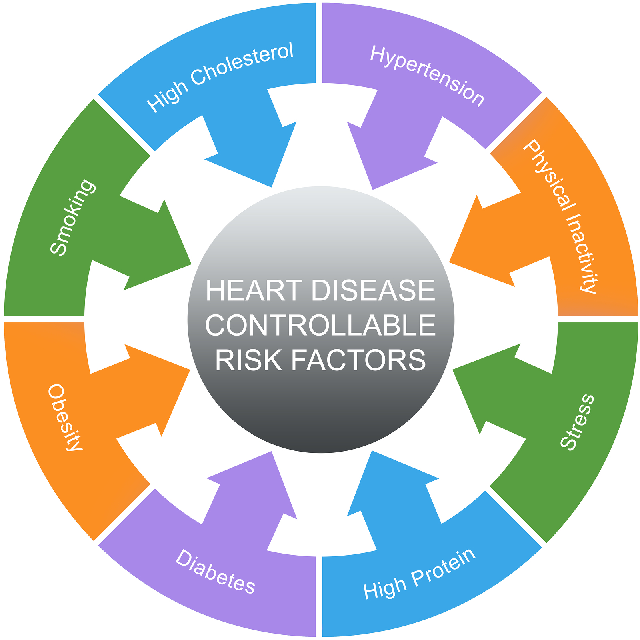There are many risk factors for heart disease. Some of these risk factors you are born with or cannot be eliminated, but may be treated to minimize. These are known as non-modifiable risk factors. Others are under your control. These are known as modifiable risk factors. There are traditional risk factors that are well known and researched and have a high probability of causing heart disease. There are also non-traditional risk factors that are not quite so well known and researched but seem to have a high probability of causing heart disease. These two grouping overlap.

* Traditional Risk Factors include:
  + Age
    - Women ≥ 55 years of age and post-menopausal women, and
    - Men ≥ 45 years,
  + Diabetes Mellitus
  + Smoking
  + High blood pressure (BP) or Hypertension
    - Hypertension is defined as resting BP > 140/90 mmHg or history of anti-hypertensives,
  + Dyslipidemia, may include one or more of the following three disorders
    1. High levels of low-density lipoprotein (LDL, also known as “bad cholesterol”)
       - This form of Dyslipidemia is defined as LDL cholesterol > 99 mg/dL,

1. Low levels of high-density lipoprotein cholesterol (HDL,also known as the “good” cholesterol)
   * + - This form of Dyslipidemia is defined as HDL cholesterol < 40 mg/dL, and
2. Hypertriglyceridemia, cause by too many triglycerides in the blood,
   * + - This form of Dyslipidemia is defined as Triglycerides > 150 mg/dL, and
   * Family history of premature coronary artery disease (CAD).
     + Premature is defined in women as < 65 years old and in men as < 55 years old,
     + This includes heart attack (ischemia or infarction).

*“Risk factors in heart disease are based on the potential for developing Atherosclerosis”*

* Non-Traditional Risk Factors:
  + Abnormal Ankle-Brachial Index (ABI)
  + Chronic stress
  + Chronic inflammation as indicated by abnormal levels of C-Reactive Protein (CRP), Fibrinogen, Lipoprotein (a), Brain Natriuretic Peptide (BNP), or Human immunodeficiency virus (HIV)
  + Homocysteine elevation
  + Microproteinuria (urinary protein excretion between 80 and 300 mg/24h, including Albumin to Creatinine ratio > 30 mg/mmol or albumin concentration > 200 mg/L)
  + Microalbuminaria (Albumin to Creatinine ratio > 2.5 mg/mmol in men or > 3.5 mg/mmol in women, or albumin concentration > 20 mg/L)
  + Metabolic Syndrome
  + Elevated serum insulin levels
  + Renal Disease
  + Abnormal Calcium Score
  + Carotid Intima-Media Thickness
  + Left ventricular (LV) hypertrophy
  + Psychosocial stresses
  + Alcohol
  + Abnormal diet
  + Clinical depression
  + Obesity, particularly of the abdominal male type
  + Sedentary lifestyle
  + Various types of infections
  + Collagen vascular diseases



* Modifiable Risk Factors (those that may be treated and negated, reversed, or diminished):
  + Smoking
  + Dyslipidemia
  + Hypertension
  + sedentary lifestyle
  + diet, obesity
  + type 2 Diabetes Mellitus or impaired glucose tolerance
  + Chronic stress
  + High CRP levels
* Non-Modifiable Risk Factors:
  + Age
  + Gender
  + Genetic abnormalities
  + Family history of premature atherosclerosis
  + African Americans. African Americans are more likely to have heart failure than people of other races. They're also more likely to have symptoms at a younger age, have more hospital visits due to heart failure, and die from heart failure
* Other causes of Heart disease includes:
  + CMP
  + CHF
  + Congenital heart diseases
  + Heart Valve dysfunction
  + Arrhythmias
  + Cancer treatments, including chemotherapy and radiation
  + Thyroid disorders
  + Substance abuses
  + HIV/AIDS;
  + Too much vitamin E
  + Obstructive sleep apnea